Locality SEND Processes:
Consultation, MyPlan QA and Panel assessment submissions
The below process has been designed by locality lead head teachers and Sheffield City Council in order to gain consistency across all localities so that professionals work collaboratively to meet the needs of children and young people with SEND in the most effective way. These processes will support schools and families to ensure quality assurance and consistency when making requests for EHC need assessments.
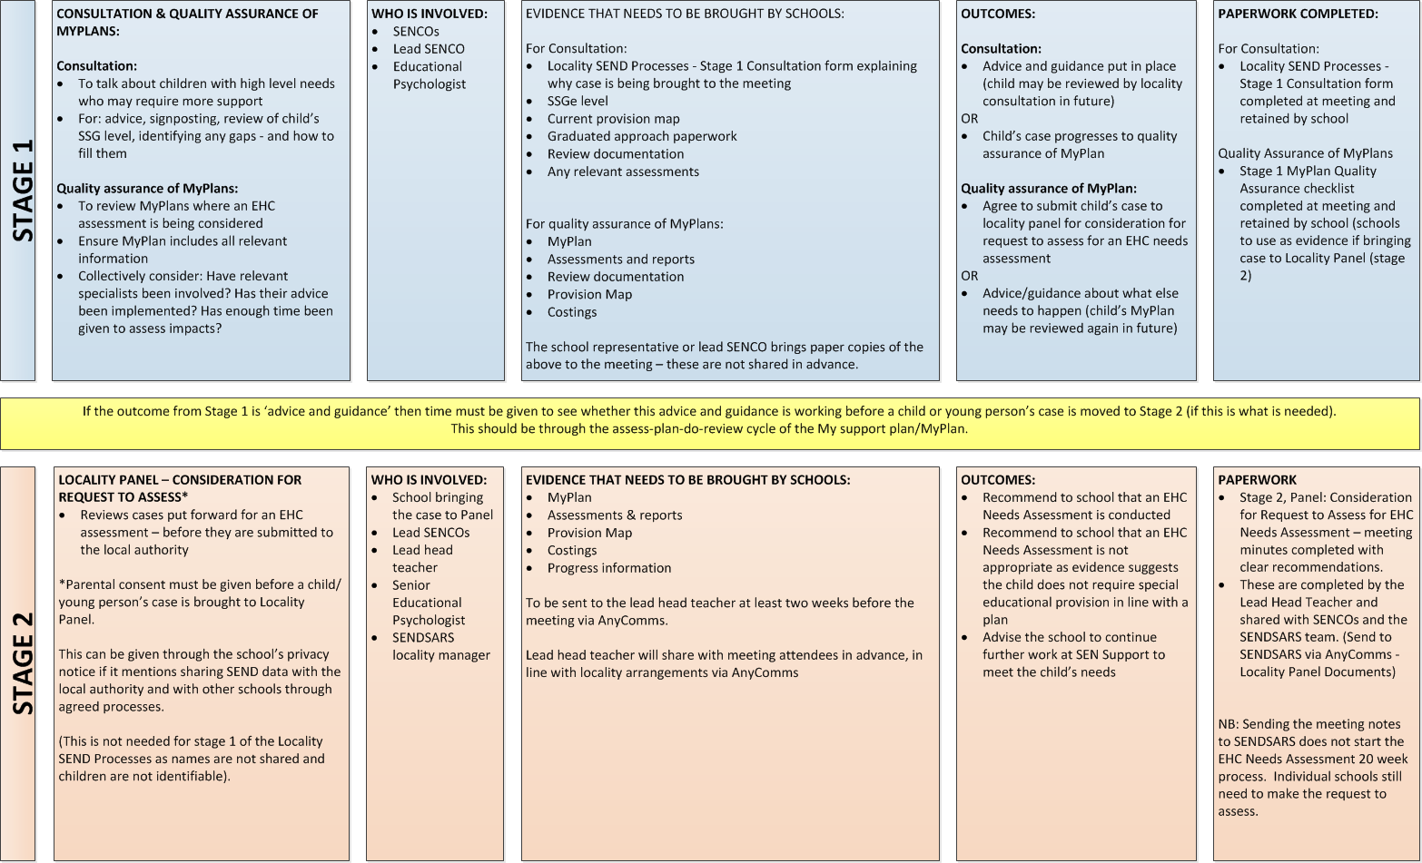

Guidance
Schools are recommended to follow the above process when seeking additional support to meet the needs of children and young people with SEND within their school. These processes have been designed to encourage collaborative work amongst SENCOs, families of schools, localities, Educational Psychologists and the SENDSARS team in order to achieve greater consistency across Sheffield.
The process is not a statutory one and does not start the 20 week EHC needs assessment process. However, the process is designed to enable schools or parents to gather essential evidence to support a request for a statutory EHC needs assessment.
Sheffield guidance, and a checklist of information that education providers must submit when making a request for an EHC needs assessment, is available on the Learn Sheffield or Local Offer website. (Please look under the Inclusion Taskforce section of the Learn Sheffield website for guidance for professionals, and see ‘Education, Health and Care Plans – Statutory processes’).

Funding
Please note that from April 2020 funding decisions for level 4 and level 5 children will be made based on the following pupil funding levels:
- Pupils at Level 4: Average of £1,500 per pupil, with a range of £0-3,000.
- Pupils at Level 5: Average of £4,500 per pupil, with a range of £3,000-6,000.
Funding decisions can be made at stage one, stage two or via a locality funding panel, depending on the arrangements already in place in each locality.
Please contact your locality lead head teacher if you have any questions about the process.

