Company No. 09734238

Special Resolution

______________________________________

Passed on 10 April 2018
______________________________________

At the EXTRA GENERAL MEETING of the above named Company duly convened and held on the above date the following was duly passed as a Special Resolution of the Company:

SPECIAL RESOLUTION

That the present Articles of Association of the Company be amended by replacing the current Articles in their entirety with the form of Articles attached

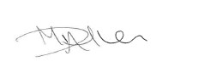

..............................................
By order of the Board

