What is The Boxall Profile?
Teachers use the Boxall Profile as a structured framework to observe children who are showing signs of social, emotional or behavioural problems at school.
Sometimes, these children may have missed out on early, nurturing relationships that are part of typical development. The Boxall provides a measure for assessing where those developmental ‘gaps’ might be. These can then be addressed in a Nurture Group setting.
A Nurture Group is a short term, structured intervention that aims to return all young people to a successful, full-time education in a mainstream setting within 2-4 terms. These groups provide structured and predictable environments where children can begin to trust adults and learn the skills they will need to succeed in a mainstream classroom.

How to use the Boxall Profile

- Each section has 34 descriptive comments (Items) to complete and a corresponding histogram to fold out on which to plot your results.

- There is a key at the top of each section that explains how to score the item-
  - according to how well the description fits the child.

Caution: A score of 4 would mean different things for each section- this is because children who would benefit from the Nurture Group intervention have low scores on the Developmental Strands section and high scores on the Diagnostic Profile.

i.e. (I) Developmental Strand: 4 = Yes, or usually
(II) Diagnostic Profile:4 = Like this to a marked extent

Children who would benefit from the Nurture Group intervention would have low scores on the Developmental Strands section and high scores on the Diagnostic Profile.
Both parts of the profile should be considered together because the sections of the Profile are related to each other- the developmental level affects the observed behaviour.

Things to consider before you fill in the Profile:
- The Profile should be completed by people who know the child or young person well enough to be able to represent their typical behaviour at school.
- It is important that the behaviour is described accurately- without making allowances for difficult home circumstances. e.g. “If you consider what he has to put up with at home, he’s usually alright”- this will give a false picture of his needs right now.
- The Boxall Profile identifies unmet developmental needs and Beyond the Boxall offers practical ways of addressing those needs.

There are 2 models of Nurture Group provision:

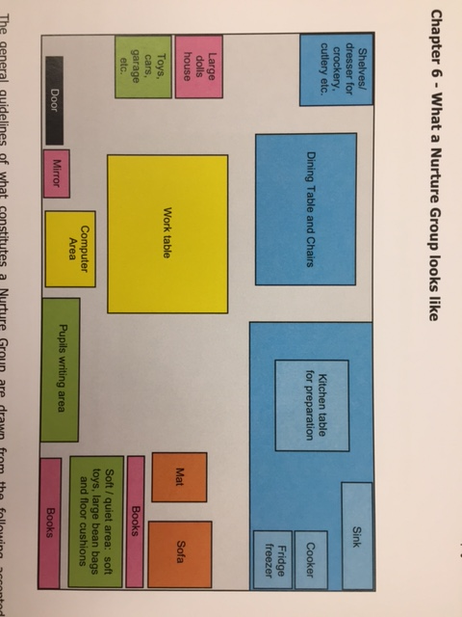

Stages in filling in the Profile
Complete the Sections one at a time.
- Look at each item in turn and decide what score you would give the child you are thinking about and enter the number (0-4) into the Score column next to the item.
- Score the child without taking their circumstances into account- the idea is to get an accurate ‘snapshot’ of how the child is right now, so that the support can be targeted correctly. For the same reason, it is important not to disregard any part of the description and talk to colleagues if it helps get a clearer picture.
- There is a space on the back page of the form (Section D) where you can add factors likely to affect the scores (e.g. EAL, visual impairment).

Once you have filled in the scores, it is time to transfer the information to the charts.
- If you look at the charts, you can see there are shaded areas at the top (Section I) or bottom (Section II). These shaded areas show the average scores for a well- functioning child. There are 10 bars on each histogram, labelled with a letter (A-J and Q-Z)
- In order to transfer the scores to the chart, you need to look at the column next to the Score column. This has a letter in it next to each item. Starting with the first item, tally up the scores and indicate the totals onto the correct bar of the chart.

The chart will give a detailed Profile for each child. Personalised plans for the Nurture Group can be developed using these profiles and identifying particular strengths and weaknesses. These need to be specifically addressed for the Nurture Group to be effective.

Use this Profile and the Beyond the Boxall handbook to plan the Nurture Group sessions

.

Review each half term
Beyond the Boxall Profile: Using the charts to plan the Nurture Group Session
The Developmental Strands are organised into 2 clusters:
- Organisation of Experience (A-E) -the most basic skills that need to be addressed first
- Internalisation of Controls (F-J) – to be addressed subsequently

The Diagnostic Profile has 3 clusters on the chart. They describe behaviours that are problematic for children’s learning.
- Self –limiting features (Q-R) need to be addressed or else progress is limited.
- Undeveloped behaviour (S-U) interferes with how a child learns to socialise appropriately.
- Unsupported Development (V-Z) describes negative behaviour towards self and others.

Attachment Theory- cycle of secure attachment
Children who do not develop a secure base will be overwhelmed by emotional experiences and may react by showing the kinds of behaviour highlighted in the Diagnostic Profile.

Attachment Theory suggests that children develop feelings of self-worth, personal identity and an ‘internal working model’ of how others will react to them through their earliest relationships.
Secure attachment is based on an intimate and continuous relationship with a primary caregiver. This internal state of security provides a ‘safe base’ from which to interact with the world.

Anyone considering setting up a Nurture Provision should complete the training.
Details can be found on the Nurture Group Network website.
https://nurturegroups.org/training
Setting up a Nurture Group
The Nurture Group aims to develop a ‘secure base’ in children who may have missed out on this in their early childhood.
The sense of safety and security is generated in a variety of deliberate and well- planned ways. It is hoped that children will rejoin their mainstream classroom within 2-4 terms.

- Environment-The surroundings are deliberately ‘homely’- it should be warm and welcoming – usually with curtains and cushions etc. There are formal work and inviting play areas and a food preparation area.
- Structure of the day- the routines are predictable and slow moving, giving children time to relax, settle and feel comfortable.
- Staff ratios- the ratios ensure that staff can provide the care-giving, attention and time that each student requires.
- Relationships- Continuity of staff is important. Children need to be able to develop trusting and enduring relationships with adults. Staff need to be consistent and give firm boundaries to contain behaviour.
- Learning- Working through challenges and difficulties in a supportive, small group environment helps children to learn how to work through their frustrations, accept that the ‘not knowing’ is OK and can experience success.

Once the Nurture Intervention has run for up to 2 terms, then staff can look at where progress has been made and identify any unmet needs. These may be addressed in further Nurture Group interventions.

How do you use the Profile to plan activities in the Nurture Group?
If you look at the columns on the completed chart, you can see the areas where the child in is having difficulties by seeing how far their score is from a ‘well-functioning child’ (shaded area).
Use the handbooks called ‘Beyond the Boxall Profile’ or ‘Beyond the Boxall Profile for Young People’. These are full of strategies and resources that match up to each column and item on the Profile. You can then use this information to plan the particular interventions and strategies you will use with that child or group of children.

The Section of the Profile is indicated

(e.g. Section II: Diagnostic Profile) Each Cluster is indicated and also colour coded (e.g. pink for the Self-Limiting Features)

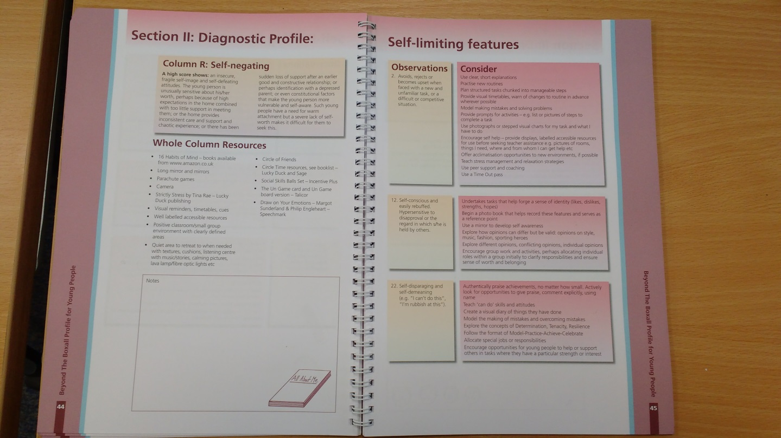
The Observations relate to each Item (question) on the Profile that contributes to this column
e.g. 2. Self-disparaging and demeaning
Consider gives ideas and resources to address this specific behaviour
e.g. Give special job within group
Each column heading is given (e.g. Self-negating) with a description of what a High or Low score means. Suggested resources for the whole column are given
e.g. Circle of Friends, Parachute games

